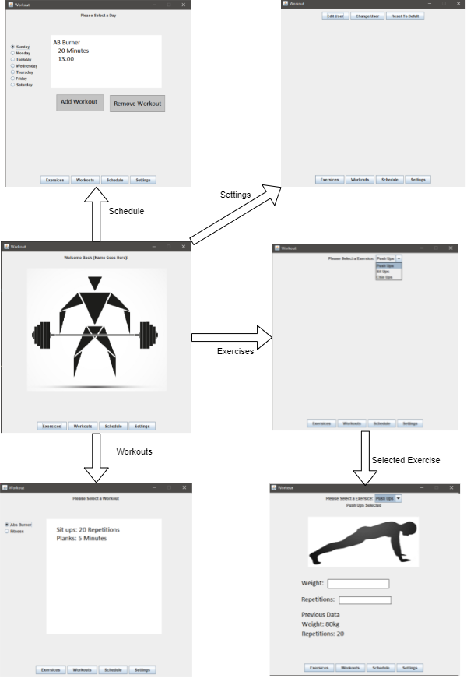

Part a)

# Part B)

The Top 3 use cases in the program are:

1. Userdata System
2. Exercise System
3. Schedule System

The userdata system is an important use case, because it provides key functionality for our user experience. This system will be significantly more appealing to new users, if there is a system in place for users to store their data between sessions. This allows users to track progress, relating to health, weight, reps, and an overall summary of themselves and their healthy lifestyle. A userdata system will provide a significant advantage over other systems that may just be a repository of exercises to do.

The exercise system is our top use case because this will require the most attention. The exercise system will consist of creating new exercises and getting them. This also includes how to store all exercises in a central database and retrieve them at a later time. All exercises will be accessed according to their type of exercise and have data associated with them such as weights involved or repetition count.

The schedule system is also an important use case. It is ranked at number three because it is an important feature for user interest but it doesn't require much work to implement. This case will show your previous week and the current week so you can keep track of all your workouts. Two weeks of workouts will be stored in the database and on the start of the third week the first week will be deleted, this will save on storage.

# Part C)

The simplest way to create and store data in a Java project is to serialize objects. That is, for each bit of data we wish to store, we simply need to create a containing class for holding the data we want, and we can serialize it and store it on file.

Each of the above use cases requires persistent memory, so all the data for each of the use cases will be serialized between sessions.

The UserData system will store information on the user, and will contain a user’s height, weight, custom exercises and workouts, and their weekly schedule.

The exercise system will be a predefined set of exercises. This will be imported from a CSV file. Each section of workouts will include a description of what body part it is focused on. This will then extend to the name of each exercise, and an item of equipment, if required.

The scheduling system will be a set of periods throughout a week, each enumerated with a date, and each contains a workout that will be done, pertaining to a section of the body.

# 

# Part D)

One challenge we have been facing is our team has never developed a graphical user interface. This is especially challenging because components are not lining up the way we had thought they would and trying to implement working UI elements within Java was a big learning curve.

Another challenge we are facing is that collaborating within a small team on the same software is challenging, especially when we all work simultaneously. Pushing changes to git and having everyone pull those changes and not write over anyone’s work was hard to manage at first, especially because all of us are unfamiliar with git.